1. For two-way binding, we combine the property and event binding. So we combine their syntax 🡺 [()]
2. 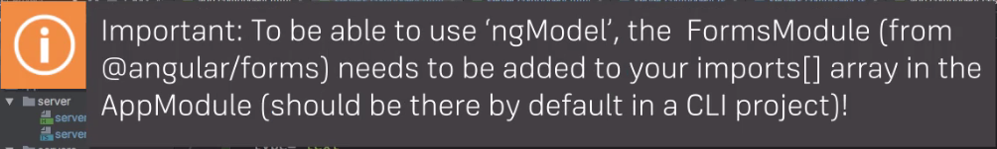
3. 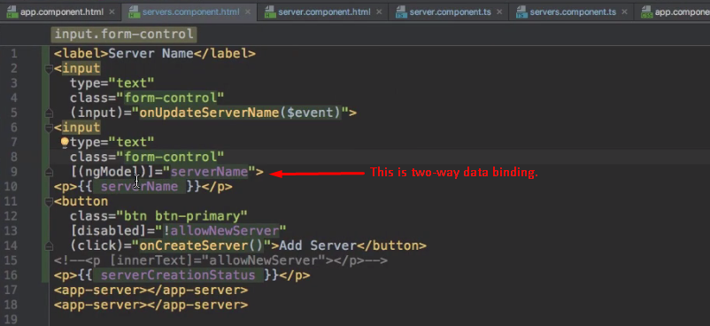
4. 